NASTP Institute of Information Technology


Submitted To: Sir Hammad

Submitted By: Huzaifa Hassan

Rollno : S2025AI036

Semester: 4th Semester – Fall 2026

Subject: ML LAB

1. OBJECTIVE
To master foundational numerical computing techniques using NumPy (ndarray), including synthetic array initialization, vertical stacking (np.vstack), multidimensional slicing, boolean masking for sensor/anomaly imputation, axis-based statistical aggregations, min-max/logarithmic mathematical transformations, and tensor reshaping/flattening.
2. THEORY
- NumPy Array (ndarray) vs Python Lists: NumPy stores homogeneous numerical types in contiguous memory blocks, enabling compiled C-level vectorization and SIMD instructions, eliminating Python pointer traversal and dynamic type checking.
- Boolean Masking & In-Place Imputation: Conditional statements on an array evaluate element-wise to generate a boolean array of identical shape ($A_{\text{mask}}=A==\text{value}$). Indexing an array with this mask extracts or assigns values in-place without explicit iteration loops.
- Axis-Oriented Aggregations: For a 2D matrix of shape $\left(M,N\right)$:
  - Axis 0 (Column-wise/Feature-wise): Collapses row indices, computing summaries down each feature across samples:
$$μ_{j}=\frac{1}{M}\sum_{i=1}^{M}{X_{i,j}}$$
  - Axis 1 (Row-wise/Instance-wise): Collapses column indices, computing metrics across all features per individual sample:
$$μ_{i}=\frac{1}{N}\sum_{j=1}^{N}{X_{i,j}}$$
- Data Normalization & Scaling:
  - Min-Max Scaling ($\left[0,1\right]$): $X_{\text{norm}}=\frac{X}{255.0}$, commonly applied to bound pixel intensities for deep neural network input layers.
  - Power/Log Transforms: Stabilize variance, reduce right-skewness, and dampen extreme outliers:
$$X_{\text{scaled}}=\log\left(X\right) \text{or} X_{\text{scaled}}=\sqrt{X}$$
- Memory Layout and Tensor Reshaping: Reshaping constructs an alternative view or copy while conserving total elements ($N_{\text{total}}=\prod{d_{k}}$). Passing -1 infers the missing dimension automatically.
3. TOOLS / SOFTWARE / LIBRARIES
- Language: Python 3.x
- Core Library: NumPy (import numpy as np)
- Environment: Jupyter Notebook / Interactive Terminal
4. PROCEDURE / METHODOLOGY
- Problem 1 (Sensor Error Imputation): Generated a 24-element 1D array of integers in range $[15,35)$. Inserted three zeros at random indices. Constructed a boolean mask selecting non-zero elements, computed their mean, and imputed all zero positions using the mask.
- Problem 2 (Inventory Matrix Restructuring): Created two 1D inventory arrays of shape $\left(6,\right)$. Vertically stacked them into shape $\left(2,6\right)$ using np.vstack. Reshaped the array into $\left(4,3\right)$ and executed 2D slicing [:, :2] to extract leading product metrics.
- Problem 3 (Academic Performance Metrics): Initialized a $\left(10,3\right)$ student grade matrix. Computed row-wise student means across axis=1 and column-wise subject maxima across axis=0. Filtered failing scores using condition scores < 40.
- Problem 4 (Medical Image Preprocessing): Generated a simulated $\left(100,100\right)$ grayscale image. Applied linear division by $255.0$ to scale bounds to $\left[0.0,1.0\right]$, executed non-linear feature transformation via np.sqrt(), and flattened the matrix to a $10,000$-element 1D vector via .reshape(-1).
- Problem 5 (Retail Pipeline): Generated two 12-month sales vectors, stacked them to $\left(2,12\right)$, set 3 values to -99, and imputed them with the valid sales mean via boolean masking. Reshaped into a 3D tensor $\left(2,4,3\right)$, flattened back to 1D, calculated regional sums via axis=1, and applied np.log() feature scaling.
5. OBSERVATIONS
- Boolean masking avoids biased summary metrics: computing mean() across the raw array with sensor errors (0) or missing flags (-99) drastically skews the baseline. Masking valid subsets produces representative imputation values.
- The -1 argument in .reshape() dynamically resolves vector dimensions without requiring hardcoded element counts.
- Axis operations strictly define dimensionality reduction: axis=1 reduces columns to produce sample-level metrics, while axis=0 aggregates observations per feature.
6. ANALYSIS / DISCUSSION
- Vectorized Imputation Efficiency: In native Python, finding and replacing anomalies requires nested loops running in $O\left(N\right)$ with high interpreter overhead. NumPy boolean indexing vectorizes this at the C-level, running in memory-contiguous blocks.
- Transformations in ML Prep: Dividing pixel matrices by $255.0$ keeps gradients from exploding during early model initialization. Applying non-linear transformations (sqrt or log) handles heteroscedasticity and long-tailed distributions typical of retail and image domains.
7. CONCLUSION
Essential numerical computing operations in NumPy—array generation, stacking, boolean mask filtering, multidimensional reshaping, axis reductions, and feature scaling transformations—were implemented. These techniques establish the vectorization principles necessary for upcoming tabular preprocessing in Pandas and data feeding in Scikit-Learn pipelines.

Task1
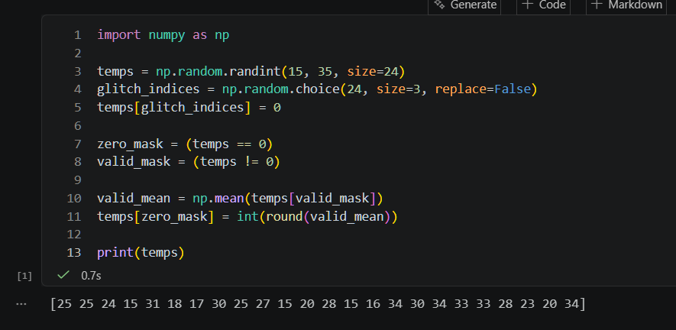

Task 2
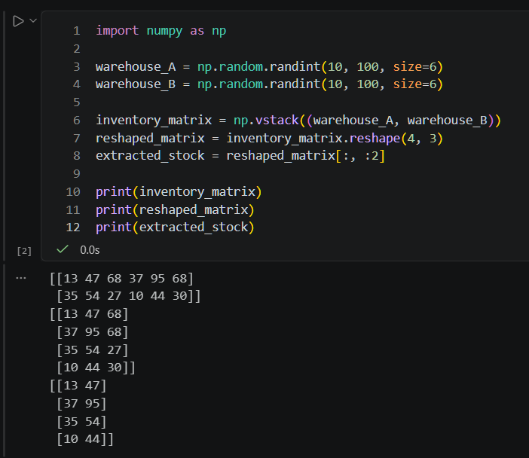
Task 3
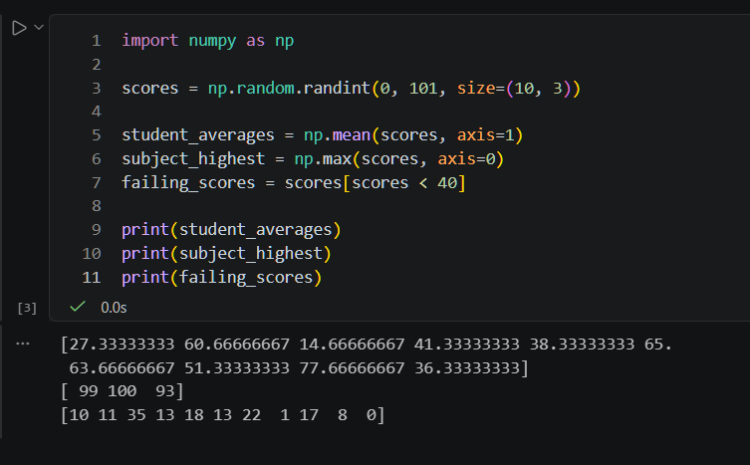

Task 4
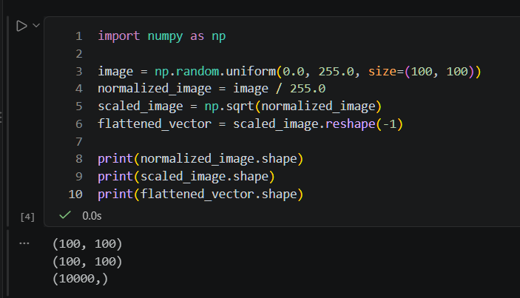

Task 5 